
SEARCHING INDEX BOOKS & OLDER RECORDS IN LAREDO
(Holmes County, OH – January, 2022)
Holmes County provides access to the following index books and older documents in Laredo:
- LEASE INDEX BOOKS 1-4 (1865-1964) (Separate Grantor & Grantee Books)
- LEASE BOOKS 1-83 (1864-1980)
- DEED INDEX BOOKS 1-13 (1801-1965) (Some are separate Grantor & Grantee Books)
- DEED BOOKS 1-156 (1812-1965)
Follow the steps listed below to search the LEASE INDEX BOOKS:
- In the Laredo “Search Group” field, click on “LEASE INDEX BOOK.”
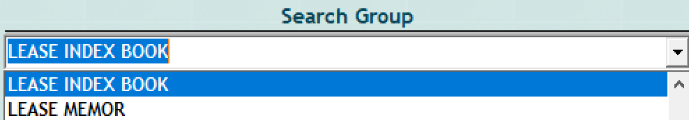

- To narrow your search to particular tabbed alphabetic pages in any of the Lease Index books, enter the first letter of the desired party’s last name in the Laredo “Party Name” field then click on the “ADD” button.
- Click on “Find.” The search results will display a list of the tabbed pages of all Lease Index books that match the selected search group and the alpha letter you entered in the “Party Name” field. In the example below, a few of the “A” pages of Lease Index books are shown.
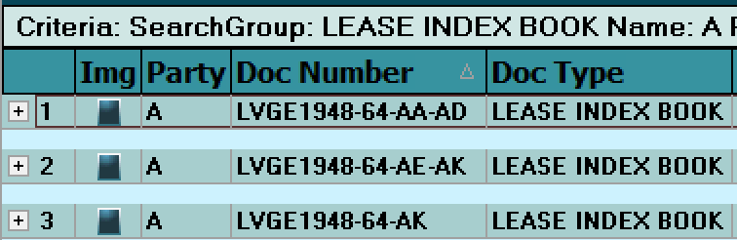

- In the “Doc Number” column, “LVGE” refers to the Grantee Lease index pages; “LVGR” refers to the Grantor Lease index pages; “LVGN” refers to the General Lease index pages; “1948-64” refers to the date range of the index book; “AA-AD”, “AE-AK”, etc. refers to the tabbed alphabetical pages within the index book.
- To order the index books by date range and alphabetical range, click on the “Doc Number” column header. An arrow pointing up will display in the column header (as in the image above). To reverse the sort order, click on the “Doc Number” column header again.
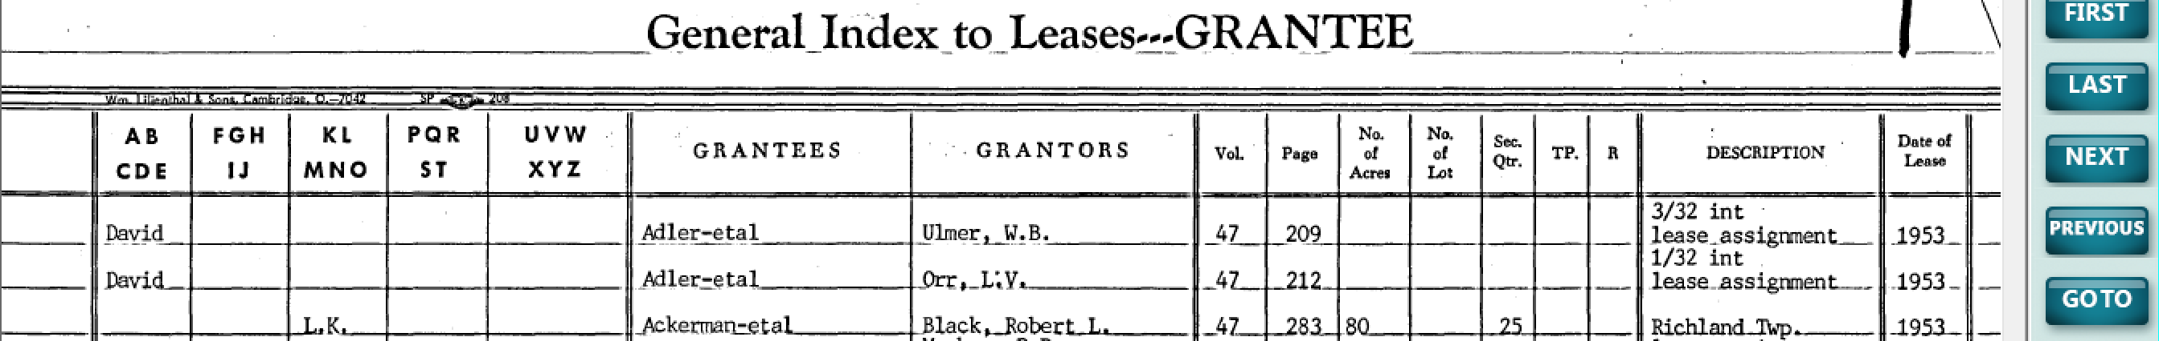
- To view a particular grouping of alphabetical pages of the desired index book, click on the value in the “Doc Number” column (e.g., “LVGE1948-64-AA-AD”) or on the image icon. The image of the selected pages of the index book will display:
- To zoom in on the image, hold the left mouse button down and drag a box around the desired portion of the image. To reset the image to the original size, right click on the image.

(Continued on next page)

Follow the steps listed below to search the DEED INDEX BOOKS:
- In the Laredo “Search Group” field, click on “DEED INDEX BOOKS.”
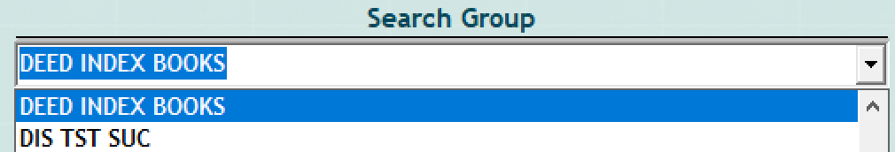

- To narrow your search to particular tabbed alphabetic pages in any of the Deed Index books, enter the first letter of the desired party’s last name in the Laredo “Party Name” field then click on the “ADD” button.
- Click on “Find.” The search results will display a list of the tabbed pages of all Deed Index books that match the selected search group and the alpha letter you entered in the “Party Name” field. In the example below, a few of the “A” pages of Deed Index books are shown.
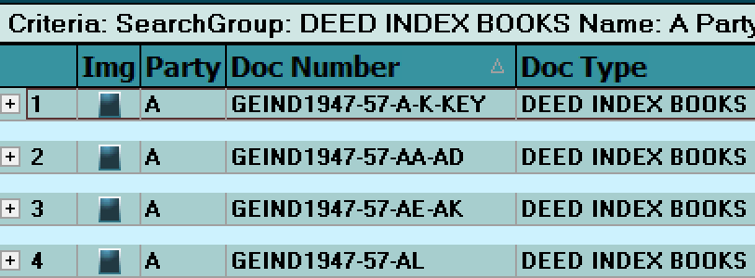

- In the “Doc Number” column, “GEIND” refers to the Grantee Deed index pages; “GRIND” refers to the Grantor Deed index pages; “IND” refers to the General Deed index pages; “1947-57” refers to the date range of the index book; “AA-AD”, “AE-AK”, etc. refers to the tabbed alpha pages within the index book; “A-K-KEY” refers to the Key pages of the designated alphabetical pages of the index book.
- To order the index books by date range and alphabetical range, click on the “Doc Number” column header. An arrow pointing up will display in the column header (as in the image above). To reverse the sort order, click on the “Doc Number” column header again.
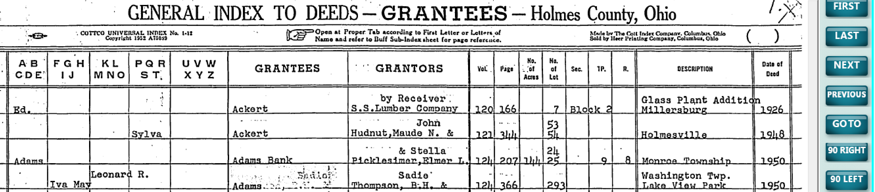
- To view a particular grouping of alphabetical pages of the desired index book, click on the value in the “Doc Number” column (e.g., “GEIND1947-57-AA-AD”) or on the image icon. The image of the selected pages of the index book will display:
- To zoom in on the image, hold the left mouse button down and drag a box around the desired portion of the image. To reset the image to the original size, right click on the image.
To search for the older Deed or Lease documents by Book (Volume)-Page value:
- In the index book image, note the values in the “Vol” and “Page” columns of the desired party name.
- Close the index book image (click on the “Done” button), click on the “Search” option on the left side of Laredo then click on “Clear.”
- In the “Book-Page” criteria field on the right side of Laredo, enter the Book value in the “Book” field and the Page value in the “Page” field (NO leading zeros or prefixes) then click on the “ADD” button.
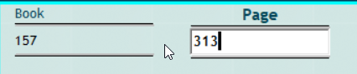

- Click on “Find.” The document will display in the Laredo search results window. Click on the value in the “Doc Number” column or on the image icon to view the image of the Deed or Lease record.
- NOTE: There may be multiple documents listed with the same Book-Page values. The prefix at the beginning of the document number will identify the document type. The prefixes for the older Lease and Deed records are:
  - LEASE BOOKS 1-83: “LV” (Ex: “LV051-0079” for the document located in Lease Book 51, page 79)
  - DEED BOOKS 1-156: “DE” (Ex: “DE001-0030” for the document located in Deed Book 1, page 30)
A NOTE ABOUT NEWER DOCUMENTS IN LAREDO:
- The index data and images for Deed documents are available in Laredo from approximately 1965 to current. These records can be searched by the index data. The document number for these newer Deed documents is in the format of “197100091027”. They are also searchable by Book-Page value.
- The index data and images for Lease documents are available in Laredo from approximately 1965 to current (as of Jan., 2022). More of these lease books are being indexed daily. These records can be searched by the index data. The document number for these newer Lease documents (from about 1980 forward) is in the format of “197100091027”. They are also searchable by Book-Page value.

